INTRODUCTION

Overview
Enhancement of online banking system with Electronic Fund Transfer capability, is a case study of My Bank. Electronic Fund Transfer refers to feature that enable bank customers to transfer fund instantly to others account through a personal computer or other intelligent device. The chances and threats that the internet symbolizes is no longer news to the present day banking sector. No traditional bank would dare face investment analysts without an Internet strategy. The main intention behind the commencement of electronic banking services is to provide the customers with an alternative that is more responsive and with less expensive options. With options just a click away, customers have more control than ever. Their expectations are usability and real-time answers. They also want personal attention and highly customized products and services.
Faster growth in network systems that use communication links to connect subsidiary system (nodes) which may send and receives, direct and redirect information. Talking of the internet a couple of years ago would have sound like a fairytale but today the internet is pervasive in almost every field of human Endeavour changing the fundamentals of how we conduct national as well as international businesses. Few years of its existence, the internet has shown that it can deliver the long sought after goal of electronic commerce. It is worth that companies in the developed countries world-wide have recognized the business potential of the internet and are getting connected to the network of networks in their millions.
The financial institution (Bank) is one of such organizations. Banking constitutes one of the most prominent life wire for Socio-Economic grow and development in any given nation, it supports and assists in the supply of long and short term loan, accepts both current sowing and fixed deposits, both foreign transactions, advice and facilitates transactions between client, workers, agents, firm, buyers and seller by providing payment services, not excluding the issue of undertaking risk on behalf of their clients, only to mention but a few. The internet having found its application and acceptance in the banking procession has particularly put the banking industry on an accelerating pace of development.
The technological highway (the internet) has become an enabler for Banks in achieving high level productivity and in handling volumes of transaction which would have been impossible without the use of on-line banking (E-commerce). The technology facilitates linkages with clients both through the provision of information and quality service delivery, as well as in reducing barriers to entry into payment systems retail banking. Internet banking allows clients to engage in informal transaction relationship which would have taken long distance travels or movement of documents with the attendant risk of loss.
With the online banking (internet) you can at your convenience, at home and at any time review account balances and transactions, transfer funds, receive and pay bills, down-load transaction services and contact customer services just to mention but a few. An over view of the benefits and prospects of the on-line banking suggest that for banks to be relevant to their customers in term of the services they provide in the twenty-first century and in the future, must append this services provided by E-commerce in the banking system in order to stay in competition. Now the on-line banking is the one thing bank should get up and invest in internet technology to reap bounteously the benefit accruing from internet banking.

1.2 Objective
- To improve in the speed, effectiveness, efficiency and convenience in business transaction.
- To enhance the running portal with extended capability to do online transactions.
- To provide an On-line banking database for My Bank using MySQL database.
- To interface the client and server side in a cost effective and efficient manner.
- To design an interface that could be used by the customer to transfer fund in others accounts.

PROBLEM ANALYSES

2.1 Problem Definition
In banking industries today, queuing has become the order of the day, customer’s line up for hours waiting to transfer money. This creates a lot of problem to both customers as they waste their useful time in the banking hall. The management also wastes their time as they run around to find solution to those problems. Also it is observed that customers cannot transfer money during bank off time.
The Bank has to update the transactions manually. A lot of paperwork and manual effort is spent in overall process. The main intent of this project is to simplify this process and configure the workflow in such a way that work becomes easy and the system becomes customer friendly.
This is a big problem as needs can arise at any time and human beings will always like to have those needs solved.

2.2 Approach
In the proposed system we are concentrating the problems whatever a client faced with existing manual system. By introducing online fund transaction module, the client provides faster services to the customer. The transaction service is available at no delay With the implementation of online transaction capability, it maintain a direct relationship with the end users via the web and are able to provide a personal characterization to the interface, by real time fund being transferred.
The system can provide information related to the different types of accounts that are existed within the bank. The system can provide the bank administration with information on the number of customers who are existence in the system. The system at any point of time can provide the information related to executed transactions by the customer.

ARCHITECTURE

3.1 System Architecture

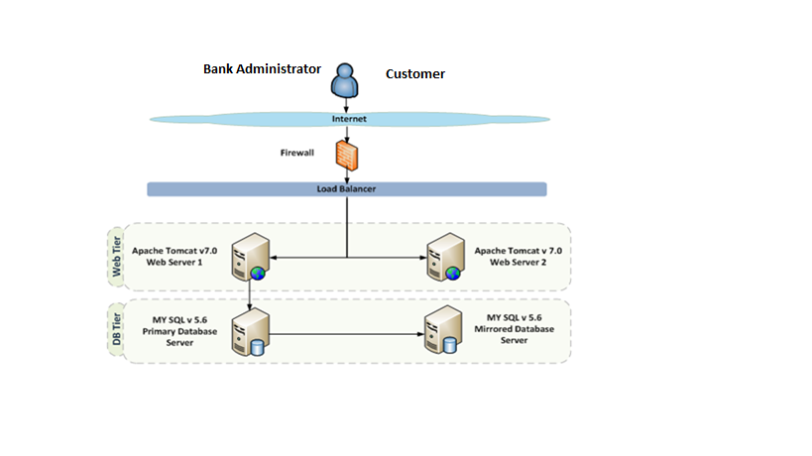
Fig:3.1

3.2 Programming Language Used
- Programming language used are HTML, JAVA script, J2EE.
- Tools Used are Eclipse, Maven.
- Database Used MySQL

3.3 Definition of Terms
- Analysis: Breaking a problem into successively manageable parts for individual study.
- Data flow: Movement of data in a system from a point of origin to specific destination indicated by a line and arrow
- Design: Process of developing the technical and operational specification of a candidate system for implements.
- Implementation: In system development-phase that focuses on user training, site preparation and file conversion for installing a candidate system
- Operation System: In database – machine based software that facilitates the availability of information or reports through the DBMS.
- Password: Identity authenticators a key that allow access to a program system a procedure.
- System: A regular or orderly arrangements of components or parts in a connected and interrelated series or whole a group of components necessary to some operation.
- System Design: Detailed concentration on the technical and other specification that will make the new system operational.
- System Testing: Testing the whole system by the user after major programs and subsystem has been tested.
- Unit testing: Testing changes made in an existing or new programs.
- Tracking Number: Unique number generated after the every fund transaction to keep the record of the particular transaction.
- Electronic fund transfer: A mechanism of sending or receiving funds from to/others accounts using internet.

DESIGN

4.1 System Flow
The data flow diagram depicts the flow of the information within the system. The system and its user act as link with all the information following into them. Customer act the source as all the request are generated by him. The record is held in the storage spaces depict by partially open rectangle. Arrows within the flow diagram is quit important as its records in a pictorial form all the information flow within the system. With the help of flow diagram we can identify the current information structure of the system. The structure of the system can thus be analyzed and it helps in making improvement within the current system.
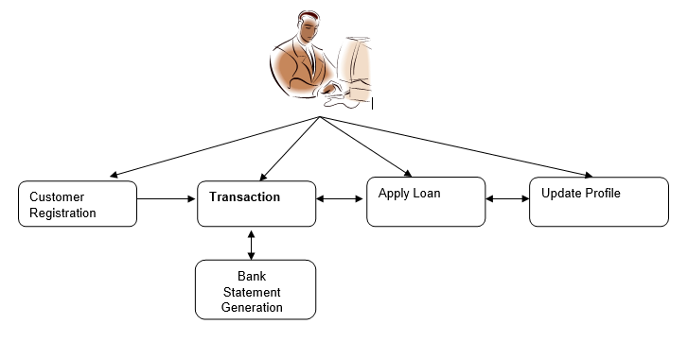
Fig: 4.1

As Per the Proposed solution, when any new customer enrolls in the bank, the customer details are gathered and stored in database. Once the registration is completed, the customers can make transactions on their accounts. The customer can withdraw, deposit and apply for loan EMI. Once the transaction is complete the customer can know his/her current account balance.

Implementation

5.1 Database Implementation
Our choice of MySQL database is due to the fact that it can be used to set up a query which, when applied to a database typically returns a set of records that matches your SQL (Structured Query Language) query. It is also used to handle large databases
Several database tables and forms were designed and implemented in this project using MYSQL (Structured Query Language) database. Each of these tables and forms has their corresponding user interface that enables the user to supply data to the system. Application table was designed for this system in order to capture the account number of each application submitted. Once an application is entered, it is automatically numbered and this is seen on top of every application / Account registration form .The account number of every application is automatically captured and stored in the account database table. In the implementation phase, the project reaches fruition. A critical phase in SLDC (System Development Life Cycle) is the successful implementation of the system; implementation simply means bringing the new system into operation.

5.2. System Object Model

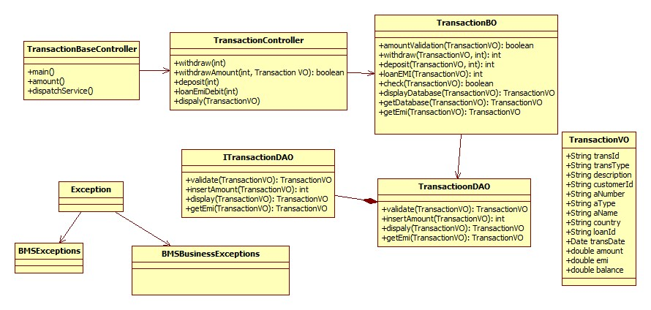
Fig: 5.2

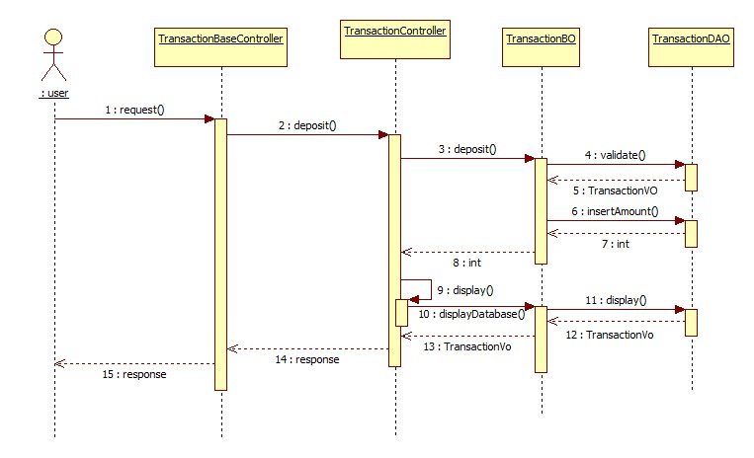
Fig: 5.3

5.3. Component Descriptions

Class | Method | Program Logic
TransactionBaseController | renderTransactionMode() | - Calls TransactionMode method to display the modes of transaction available-withdraw,deposit,loan EMI debit..
 | TransactionMode() | - Displays the modes of transaction- EMI payment, transfer.  - The customer enters the transaction mode.
 | doTransaction ()  Parameters  transactionType  Return Type  Service method of requested Trans Type | - This method calls different transaction in in the TransactionController with service as the parameter according to the selection made by the customer.
TransactionBO | amountValidation  Parameters  TransactionVO transactionVO  Return Type  boolean | - Checks whether enough fund is there in the account for the transaction to be done.
TransactionBO | ValidateAccNum()  Parameters  TransactionVO transactionVO  Return Type  boolean | - Checks whether account number is there in the database.
TransactionBO | getDataBase()  Parameters  TransactionVO transactionVO  Return Type  transactionVODB | - Calls validate method in the TransactionDAO with transactionVO as the parameter to get the database values.
TransactionBO | displayDatabase()  Parameters  TransactionVO transactionVO  Return Type  transactionVODB | - Calls display method in the TransactionDAO with transactionVO as the parameter to get database values.
 | ValidateCustomerDetail()  Parameters  TransactionVO transactionVO  Return Type  transactionVODB | - Gets the customer details and account details from the database.
 | displayConfirmation()  Parameters  TransactionVO transactionVO  Return Type  transactionVODB | - Gets the transaction details from the database.

Table: 5.3.1

5.4. User Interface Controls

Data Element | Control type | Default Values | Editable Field | Restrictions | Mandatory/  Non Mandatory | Data Type | Data  Size
Name | Textbox | No | Yes | Only Alphabets | Mandatory | Varchar | 30
Username | Textbox | No | Yes | Only Alphabets | Mandatory | Varchar | 30
Password | Textbox | No | Yes | Only Alphanumeric and special char | Mandatory | Varchar | -
Re-type Password | Textbox | No | Yes | Only Alphanumeric special char | Mandatory | Varchar | 50
Guardian Type | Combo box | No | Yes | Only Alphabets | Mandatory | Varchar | 30
Guardian Name | Textbox | No | Yes | Only Alphabets | Mandatory | Varchar | 30
Address | Textbox | No | Yes | Only Alphanumeric | Mandatory | Varchar
Citizenship | Combo box | No | No | Only Alphabets | Mandatory | Varchar
State | Combo box | No | No | Only Alphabets | Mandatory | Varchar
Country | Combo box | No | No | Only Alphabets | Mandatory | Varchar
Email Address | Textbox | No | Yes | Only Alphanumeric | Mandatory | Varchar | 50
Gender | Combo box | No | No | Only Alphabets | Mandatory
Marital Status | Combo box | No | Yes | Only Alphabets | Mandatory | Varchar
Contact no | Textbox | No | Yes | Only Numeric | Mandatory | Num | 10
Date of Birth | Textbox | No | Yes | Valid Date format | Mandatory | Date
Registration Date | Textbox | Yes | Yes | Valid Date format | Mandatory | Date
Account type | Combo box |  | Yes | Only Alphanumeric | Mandatory
Branch Name | Combo box | No | Yes | Only Alphabets | Mandatory | Varchar | 30
Citizen status | Textbox | No | No
Initial Deposit Amount | Textbox | No | Yes | Only Numeric | Mandatory | Num | 10
Identification Proof Type | Combo box | No | Yes |  | Mandatory
Identification Document No | Textbox | No | Yes | Only Alphanumeric | Mandatory | Varchar | 30
Reference account holder name | Textbox | No | Yes | Only Alphabets | Mandatory | Varchar | 30
Reference account holder acc. No | Textbox | No | Yes | Only Alphanumeric | Mandatory | Varchar | 30
Reference account holder address | Textbox | No | Yes | Only Alphanumeric | Mandatory | Varchar | 50
Alternate Address | Textbox | No | Yes | Only Alphanumeric | Mandatory | Varchar | 50
Alternate Contact Number | Textbox | No | Yes | Only numeric | Mandatory | Varchar | 50

Table: 5.4.1

SUMMARY

A summary of the achievements of this project, the existing system was analyzed, after which information were gathered followed by the analysis of those data. Based on the analysis, the limitations of the existing system were identified which initiated the choice of this project topic. This was followed by the system design, specification, database design, client side design, server side design, interface design and system security design. The implementation of these designed units was carried out successfully. After the design and implementation of the various units, system testing was carried out both on unit and general testing basis using test data to check the expected and actual test result. Finally, the performance evaluation of the system was certified since it is doing what it was designed to do.

REFERENCES

Fluaghter, R. (1990), Computerized Adaptive Testing, Hillsdale, New York: ACM press.
Glass, H. (2000), Interpretation of International Banking System, New Jersey: Vintage publication.
Klausmeier, J. (1984), Networking and Microcomputers Eric Digest NY, Clearing House on Information Resources, New York: Academic press.
Lewis, I. (2001), Computerization of Banking Systems, New York: Pearson Publication.
Molina, J.K. (1997), Item Banks Information Storage and Management.
Olea, J. & Prieto, G. (1999), Tests Information: Fundamental Application. Educational Research, Washington DC: DP Publication ltd.
Renom, J. (1997), Perspective Tests Adaptive Information, New York: Yarchi Press.
Sands, W. (1997), Computerized Adaptive Testing, American Psychological association, Washington DC: McGraw Hill.
Vossen, G. (1991), Data Models, Database Languages. And Database Management Systems Adison-Wesley Publishing, New Orleans: Pitman Publication.
Wise, S., & Kingsbury, G. (2000), Practical Issues in Developing and Maintaining a Computerized Adaptive Test: Fundamental Application, New York: ACM Press.

APPENDIX A
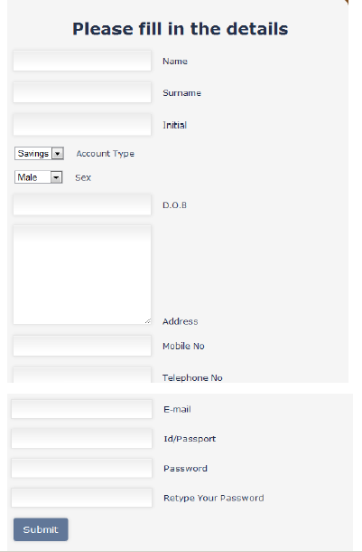



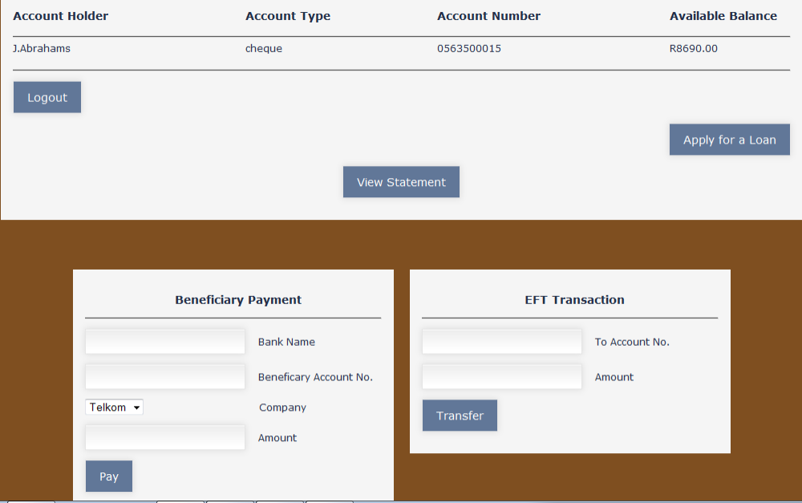

Project Review Evaluation Sheet

Components Distribution | Marks Awarded
Problem definition, motivation and objective (3)
Literature Survey or related work (3)
Preliminary design and module description (3)
References (1)
Total (Out of 10)

Madhusudan Pisupati
SUPERVISOR,
Senior Associate - Projects,
Cognizant Technology solutions.
Signature of Internal Guide with Name

